Type of Article
Title of the article in the original language
(original language of the article - maximum 15 words and should be informative, succinct, written in the affirmative, without abbreviations and without mentioning place of investigation)
Translation of the Title
(if the original language is not English, it is mandatory to place the English translation)
Translation of the Title
(in case of another languages)

Full name of the author, ORCID, Contribution CRediT¹
Full name of the author, ORCID, Contribution CRediT²

¹ Affiliation of the author - must contain up to three levels (e.g. University, Faculty, Department), City and Country.
² Affiliation of the author - must contain up to three levels (e.g. University, Faculty, Department), City and Country.

Authors mailing address

HISTORY (internal journal register)
Received:
Approved:

Abstract in the original language
Abstract and keywords are required in the original language of the article text and in English, when this is not the original language – It must not exceed 150 words.

Keywords: (Each of the keywords must be separated by comma or semi-colon - Must not exceed 5 keywords)

Translated Summary
Abstract and keywords are reequired in the original language of the article text and in English, when this is not the original language – It must not exceed 150 words
Keywords: Each of the keywords must be separated by comma or semi-colon – Must not exceed 5 keywords

Section
Body – in justified text

Subsections
Body – in justified text
Long direct quote (40 or more words) (if applicable) - Font size 12, left margin of 4 cm
You can see an example below:
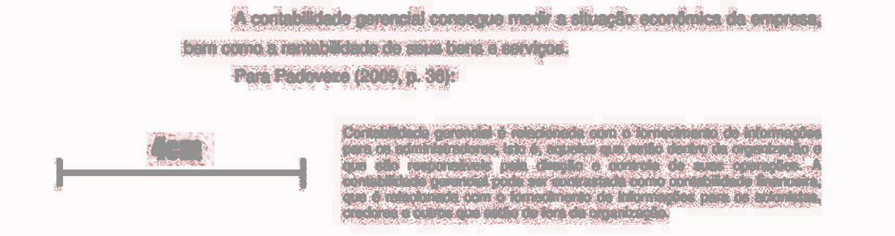

Tables (if applicable: It is important to note that in text tables, the column title (not the table ID/legend) should be in bold and the text content data in normal. Scientific names must be in italic.
You can see an example below:
Table 1: table legend/ID
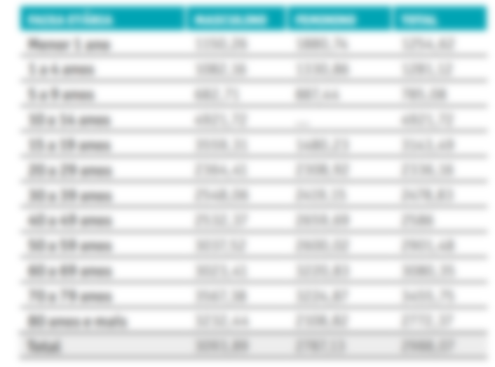
If there is any, reference/source of the table

Charts and Figures (if applicable)
You can see an example below:

Reference/Figure Source
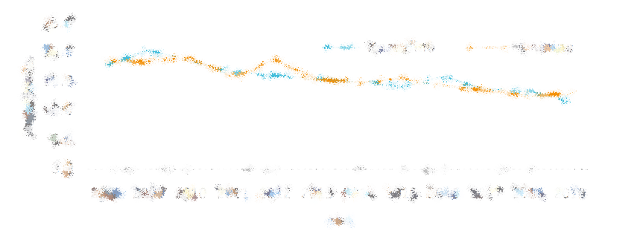
Figure 1: legend/figure ID

Images: Must be in the body of the text, inserted in format . png or . jpg and centered. Images must be in line with the text.

Acknowledgments
(or equivalent in another language)
If applicable - Refer to Institutions, Entities or Persons.

References
References must be in accordance with the Vancouver bibliographic style.

Biographical Notes
If applicable - Author information as a mini-curriculum.

Financing
Inform the names of public or private institutions that have supported financially, with technical assistance or other support. Include the process number, if applicable.

Approval by the Ethics Committee
Approved by the Ethics Committee of [refer institution], opinion no. [000.0000/2022], Certificate of Ethical Assessment document [identify request]

Conflict of Interest
Inform whether or not there is a conflict of interest.

Appendices, Appendixes and Glossaries and other materials
(If applicable - if these materials are extensive, files should be in PDF format).

